ΛΑΜΑΡΙΝΑ ΤΥΠΟΥ ΚΕΡΑΜΥΔΙ
METAL TILE ROOFING SHEET

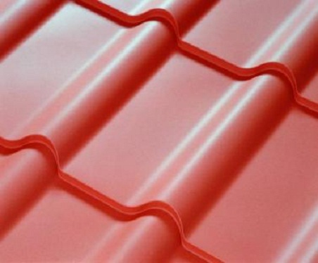

ΣΕΙΡΕΣ ΚΕΡΑΜΙΔΙΩΝ  TILE SERIES | ΜΗΚΟΣ  LENGTH  m | ΒΑΡΟΣ  WEIGHT  kg
 |  | 0.40 | 0.45 | 0.50
1 | 0.49 | 2.08 | 2.34 | 2.60
2 | 0.84 | 3.44 | 3.87 | 4.30
3 | 1.19 | 4.88 | 5.49 | 6.10
4 | 1.54 | 6.32 | 7.11 | 7.90
5 | 1.89 | 7.76 | 8.73 | 9.70
6 | 2.24 | 9.20 | 10.35 | 11.50
7 | 2.59 | 10.64 | 11.97 | 13.30
8 | 2.94 | 12.08 | 13.59 | 15.10
9 | 3.28 | 13.52 | 15.21 | 16.90
10 | 3.64 | 14.98 | 16.83 | 18.70
11 | 3.99 | 16.40 | 18.45 | 20.50
12 | 4.34 | 17.76 | 19.98 | 22.20
13 | 4.69 | 19.20 | 21.60 | 24.00
14 | 5.04 | 20.64 | 23.22 | 25.80
15 | 5.39 | 22.08 | 24.84 | 27.60

